**Registration Form**

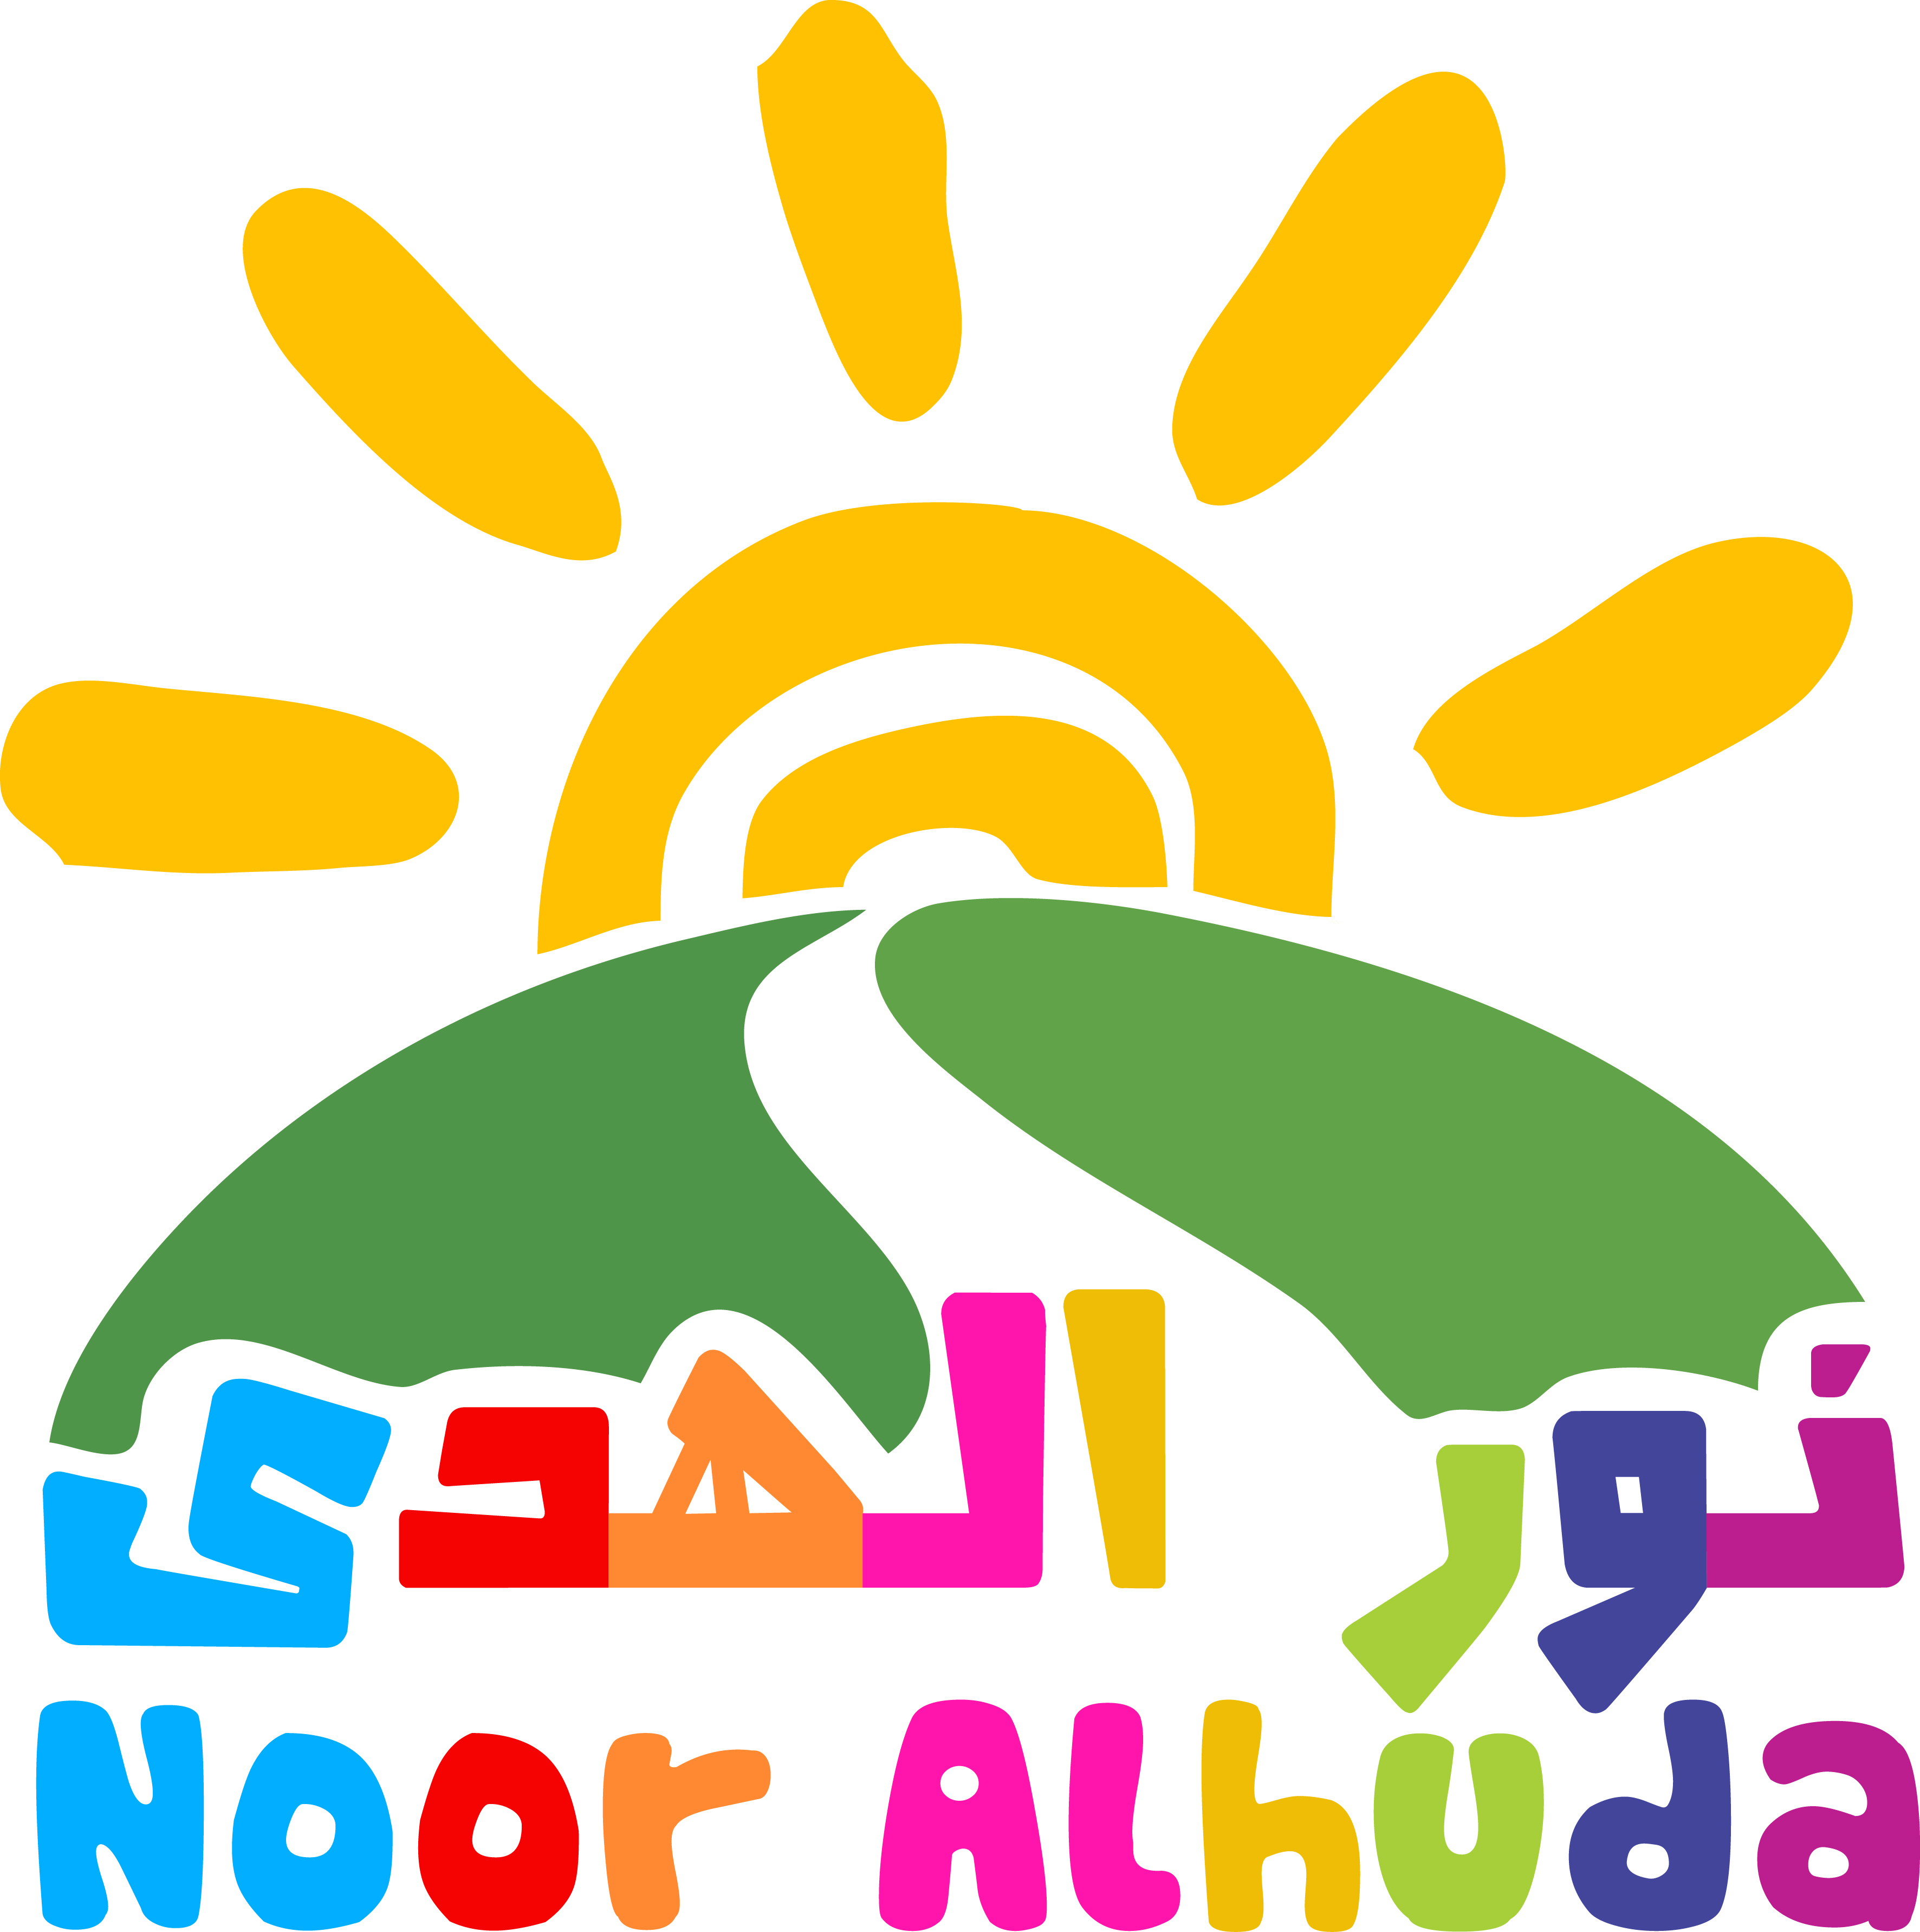

**مدرسة نور الهدى العربية**

**NOOR ALHUDA ARABIC SCHOOL**

Photo/ **صورة**

**Head office:** 4 Dalston Gardens, Stanmore, HA7 1BU

**T:** 020 8204 1167 – **T**: 020 3235 2098

info@nooralhuda.org.uk - www.nooralhuda.org.uk

**STUDENT DETAILSتفاصيل الطالب**

|  |  |  |  |  |  |  |  |  |  |  |  |  |  |
| --- | --- | --- | --- | --- | --- | --- | --- | --- | --- | --- | --- | --- | --- |
| **Surname** | **اللقب** | | **Father’s name** | | **الأب** | | | | | | **Student’s name** | **اسم الطالب** | |
|  | | |  | | | | | | | |  | | |
| **Arabic Class** **العربي الصف الحالي:** | | |  | | | | | |  | | | | |
| **STUDENT’S ADDRESS** | **: عنوان الطالب** | | | | |
| **Address Line 1:** | | | | | | **Date of birth**: **تاريخ الولادة** / | | | | | | |  |
| **Address line 2:** | | | | | | **Gender** الجنس /: | | | | | | |  |
| **Address line 3:** | | | | | | **English School**  : اسم المدرسة | | | | | | |  |
| **Postcode:** | | | | | | **English School Year**  الصف الحالي الانكليزي : | | | | | | |  |
| **FAMILY DETAILS- The person(s) below will have authority to pick up the student**  **تفاصيل العائلة** | | | | | | | | | | | | | |
| **Mother full name اسم الأم مع اللقب** | |  | | | | | | | | | | | |
| Mobile telephone تلفون الموبايل | |  | | | | | | | | | | | |
| Home telephone تلفون البيت | |  | | | | | Email | | |  | | | |
| Home address عنوان البيت  *(if different from above)* | |  | | | | | | | | | | | |
| **Does this parent have parental responsibility for the Student? Yes □ No □**  **هل أنت المسؤول المباشر على الطالب** | | | | | | | | | | | | | |
| **Father full nameاسم الأب واللقب** | |  | | | | | | | | | | | |
| Mobile telephone تلفون الموبايل | |  | | | | | | | | | | | |
| Home telephone تلفون البيت | |  | | | | | Email | | |  | | | |
| Home address عنوان البيت  *(if different from above)* | |  | | | | | | | | | | | |
| **Does this parent have parental responsibility for the Student? Yes □ No □** | | | | | | | | | | | | | |
| |  |  |  |  |  | | --- | --- | --- | --- | --- | | **EMERGENCY CONTACT DETAILS:**  These people will have authority to collect the child | | | **اسم الشخص في حالة الطوارئ** | | |  | **Name** | **Relationship** | | **Mobile Number** | | **1** |  |  | |  | | **2** |  |  | |  | |  | | | | | | | | | | | | | | | | | | |
| **STUDENT MEDICAL INFORMATION:** | | | | الحالة الصحية للطالب | | | | | | | | | |
| **Does your child have any on-going medical conditions?**  هل يعاني ابنك / ابنتك من أية حالة مرضية/ الرجاء ذكرها؟ | | | | | | | |  | | | | | |
| **Is your child known to have any allergies?**  هل يعاني ابنك / ابنتك أي حساسية الرجاء ذكرها؟ | | | | | | | |  | | | | | |
| **Does your child have any special needs or disabilities?**  هل ابنك / ابنتك من ذوي الاحتياجات الخاصة أو يعاني من العوق؟ | | | | | | | |  | | | | | |
| **Would you like to add any information about your child?**  **هل تود ان تضيف أية معلومات أخرى تخص ابنك/ ابنتك؟** | | | | | | | |  | | | | | |

|  |
| --- |
| **Noor Alhuda Boys and Girls** (age 4 -8) |
| **Claremont High School**  **Claremont Ave, Kenton**  **HA3 0UH** |
| Tel: 07944 647 092 **Weekdays 10-3pm** |

**PHOTOGRAPHY CONSENT-** Our Schools are committed to the protection of children and vulnerable adults involved in our activities. Staff acting on behalf of the schools sometimes take photographs or videos for publicity purposes. These images may appear in our printed publications, on our website, or both. Before taking pictures we need your permission. Please tick the means of which you allow us to share and use the photos.

**الرجاء ضع علامة صح إذا لم يكن لديكم مانع من تصوير ابنكم \ ابنتكم خلال تواجدهم في المدرسة و عرضها على**

|  |  |  |  |  |  |
| --- | --- | --- | --- | --- | --- |
| **Website** |  |  | **WhatsApp** |  |  |

|  |  |  |  |
| --- | --- | --- | --- |
| **POLICIES AND PROCEDURES**  I have been provided with details of School’s policies and procedures, and understand I can receive as well them on the website and at the head office. I have also received the Student Handbook and accept the terms and conditions.   |  |  | | --- | --- | |  | **لقد تم تزويدي بتفاصيل نظام المدرسة ويمكنني الحصول عليها كذلك من الموقع الخاص بالمدرسة أو المكتب الرئيسي. لذلك أوقع وأوافق على كافة الشروط**  **استلام نظام المدرسة و الموافقة عليه**  نظام المدرسة | | |
| **Signed** | **Date** |